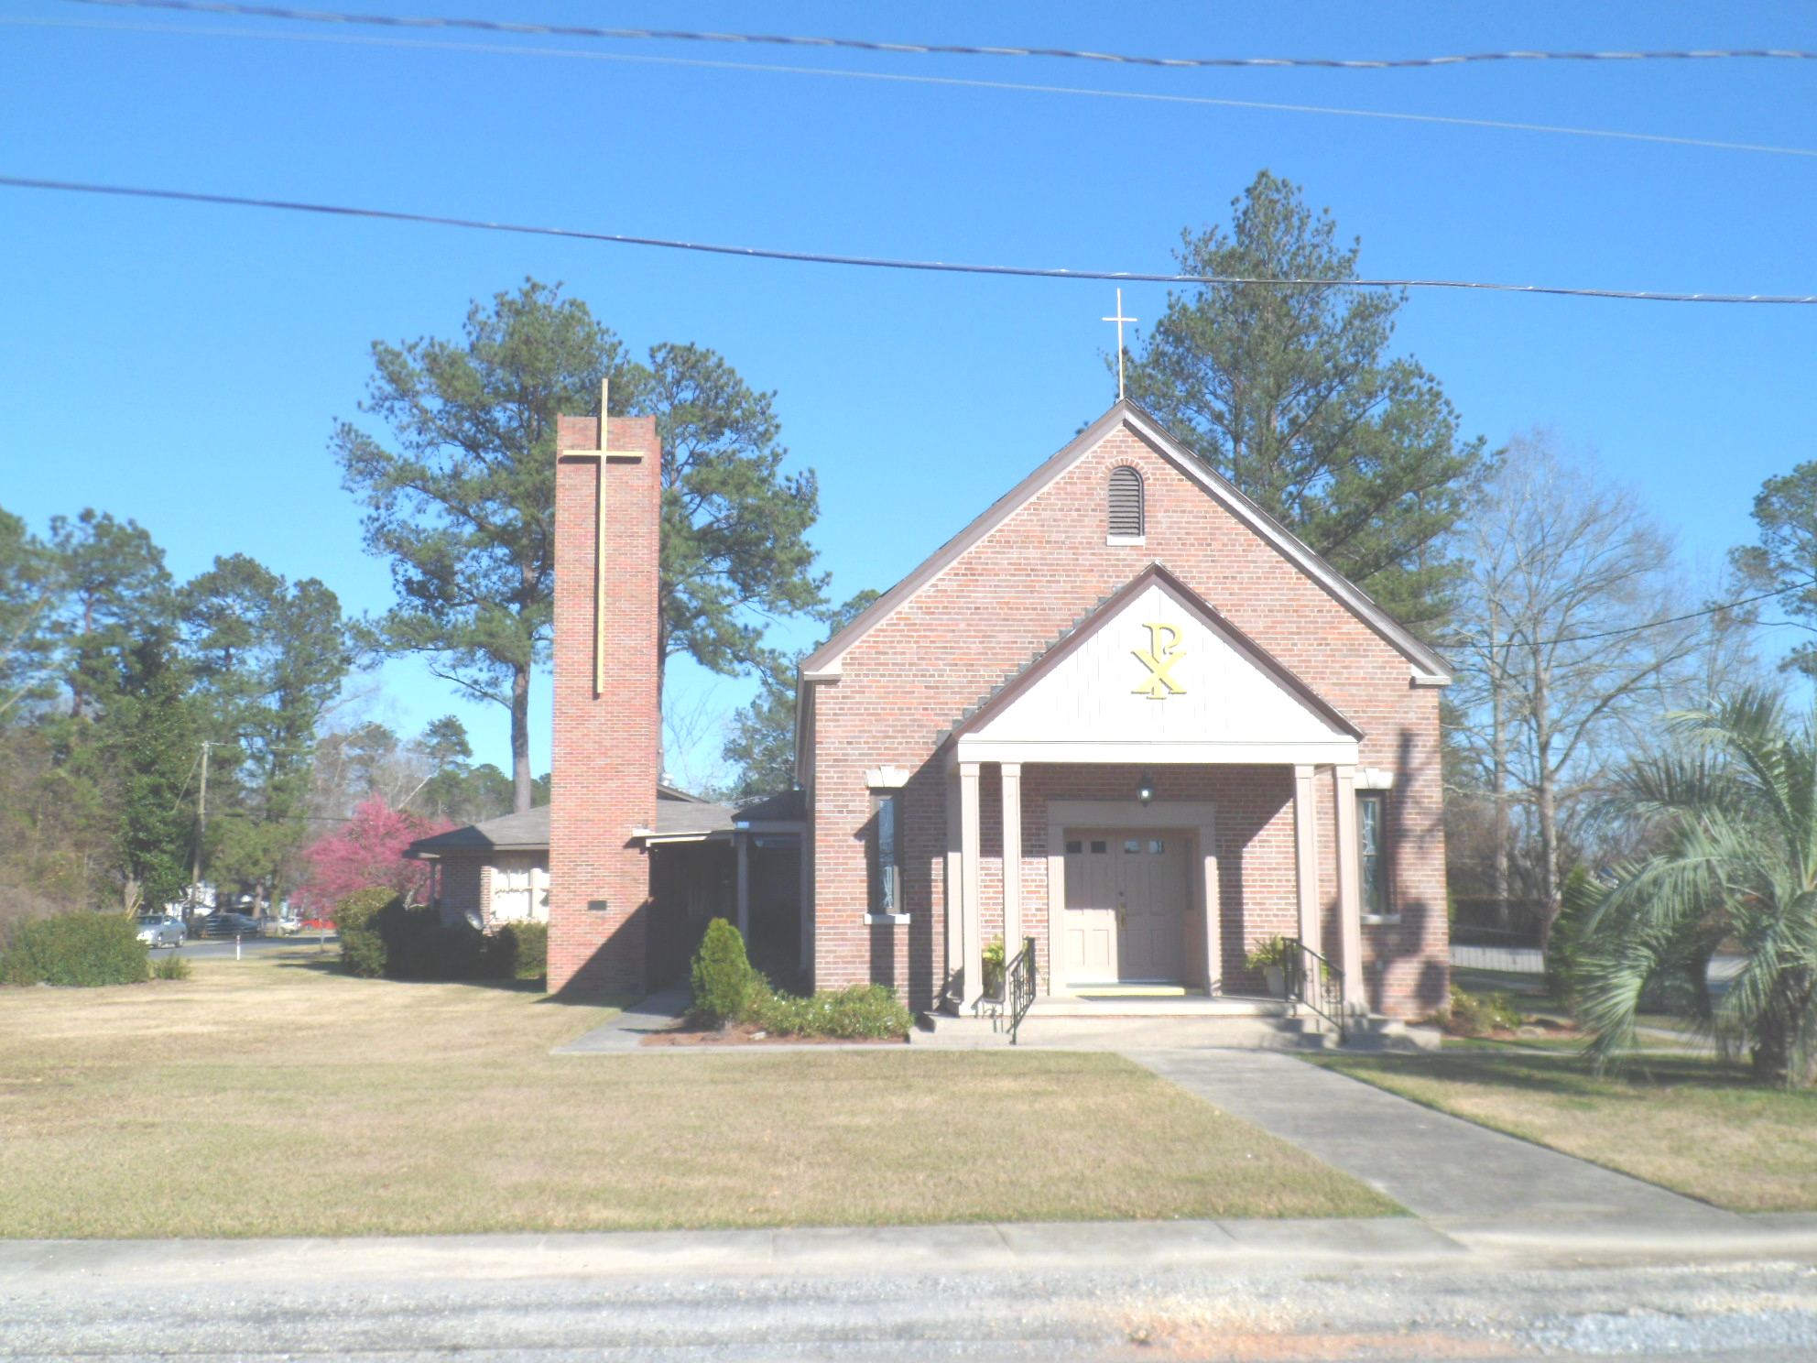
St. Maurice Catholic Church

202 East Jackson St. / P.O. Box 206
Brewton, AL 36427-0206
Rectory: 251-867-5189
Pastor: Rev. Patrick J. Madden
Fr. Pat’s cell # 251-769-3324
pshamrock72011@gmail.com
Deacon Stephen Tidwell- 251-369-3157

Sacrament of Reconciliation: Sat. 5-5:30 PM and anytime by appointment.
BAPTISM: Please contact pastor when you anticipate a baptism in the near future.
WEDDINGS: Please contact pastor/ or deacon at least 6 months prior to the
anticipated date and meet with him for preparation.
ILLNESS: Please contact the Rectory & leave a message, or call Fr. Pat’s cell
number, when a parishioner is ill or in the hospital.

PARISH COUNCIL MEMBERS Finance Committee
- Kelly Davis – Communications 251-363-9362 Ann Peach - 251-363-3313
- Allison Nalty – Social 251-363-3036 Johnny Allan - 251-538-1126
- Deacon Steve Tidwell 251-369-3157 Synod Committee
- Wiley Downing – Finance 251-362-0166 David & Mayra Seitz
- Trish Noble – Youth 251-564-4404 251-538-0238

DAILY MASS – Monday, Tuesday, Wednesday & Friday 8:00 am Religious Education- Sunday School meets 2x monthly-2nd/4th Sunday’s

WEEKEND MASS: Saturday, 6:00 PM; Sunday, 8:30 AM
Hispanic Mass – Second and Last Sunday of the Month

(Regular Weekend Mass schedule of Saturday Vigil Masses remains in effect

September 18 8:30am Mass-Rev. David Chantal is sharing a scriptural
reflection.
September 25 8:30am Mass & Spanish Mass 11am.
October 2 8:30am Mass

Twenty-fifth Sunday in Ordinary Time September 18, 2022

Collection RESULTS: Weekend September 11 - $2,011.00 Debt reduction- $110.00
Our parish website is http://saintmauricebrewton.org/
Log on and see what’s next.

. This Sunday, Rev. David Chatel (St. Stephen’s Episcopal Church) and I will be swapping pulpit’s; also, a meal will be served for everyone following the 10am service at St. Stephen’s.

. Jesus teaches his disciples an important lesson
About wealth in today’s Gospel. In the parable he tells them, the clever steward is applauded for finding a way to maintain his wealth despite losing his job. But this kind of wealth is not what is truly important, for true wealth is found in God. We cannot allow money(mammon) to be our master. Today, on Catechetical Sunday, let us be reminded that Jesus, our teacher, continually teaches us the way to eternal dwellings.

