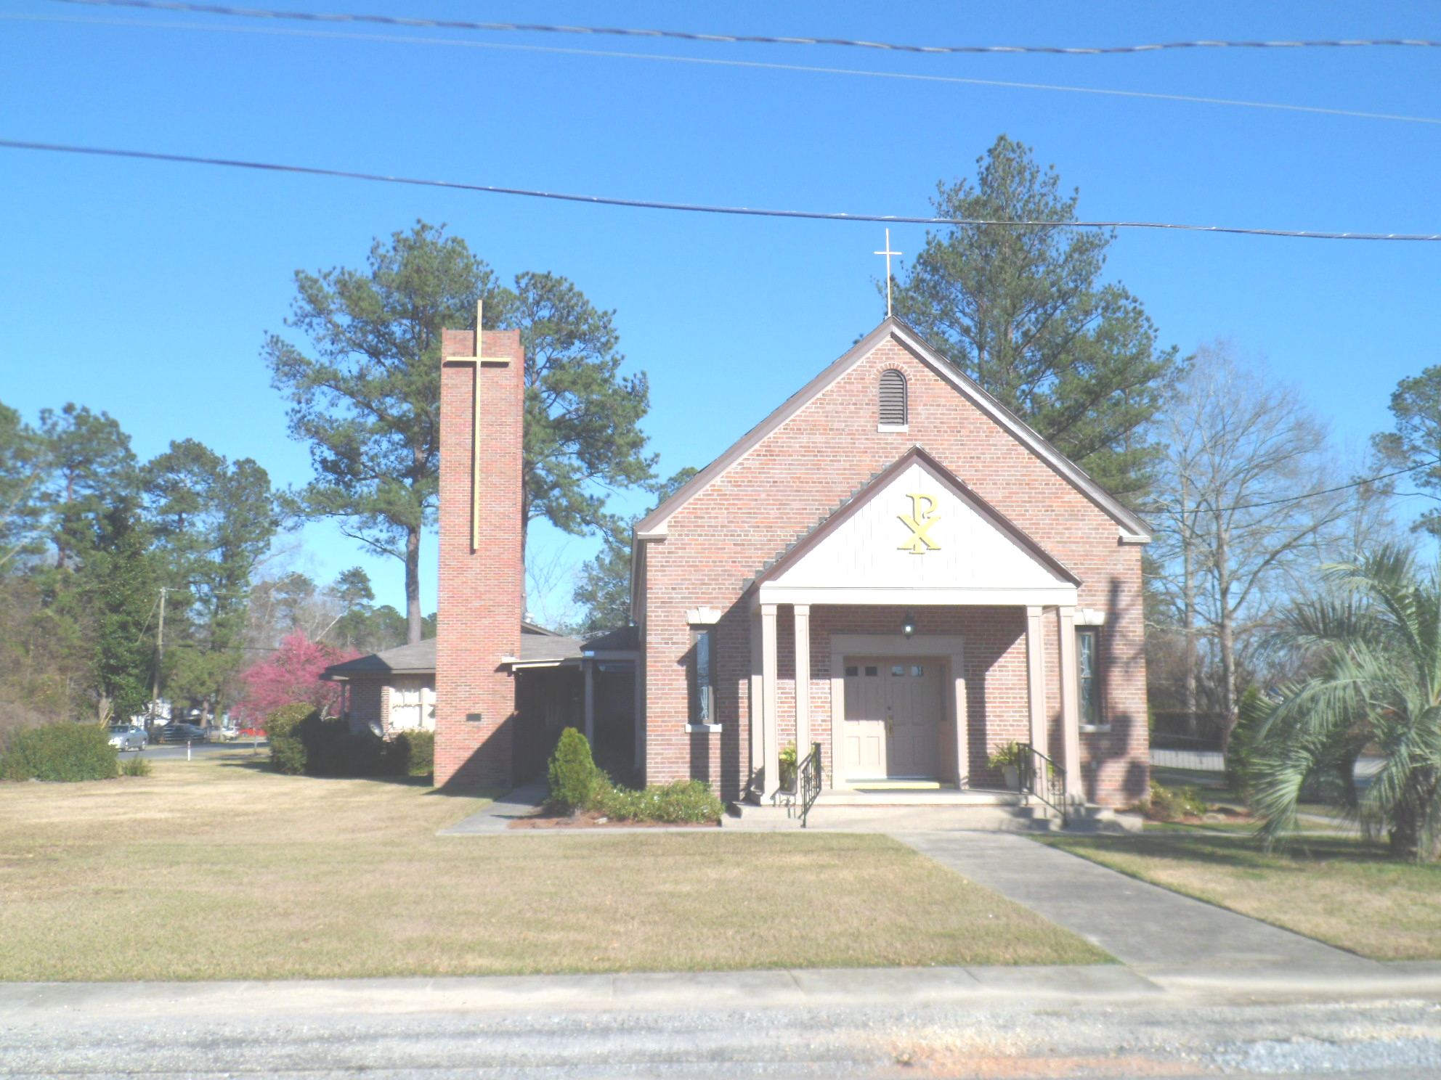
St. Maurice Catholic Church

202 East Jackson St. / P.O. Box 206
Brewton, AL 36427-0206
Rectory: 251-867-5189
Pastor: Rev. Patrick J. Madden
Fr. Pat’s cell # 251-769-3324
pshamrock72011@gmail.com
Deacon Stephen Tidwell- 251-369-3157

Sacrament of Reconciliation: Sat. 5-5:30 PM and anytime by appointment.
BAPTISM: Please contact pastor when you anticipate a baptism in the near future.
WEDDINGS: Please contact pastor/ or deacon at least 6 months prior to the
anticipated date and meet with him for preparation.
ILLNESS: Please contact the Rectory & leave a message, or call Fr. Pat’s cell
number, when a parishioner is ill or in the hospital.

PARISH COUNCIL MEMBERS Finance Committee
- Kelly Davis – Communications 251-363-9362 Ann Peach - 251-363-3313
- Allison Nalty – Social 251-363-3036 Johnny Allan - 251-538-1126
- Deacon Steve Tidwell 251-369-3157 Synod Committee
- Wiley Downing – Finance 251-362-0166 David & Mayra Seitz
- Trish Noble – Youth 251-564-4404 251-538-0238

DAILY MASS – Monday, Tuesday, Wednesday & Friday 7:30 am Religious Education- Not active ; Confirmation class begins Jan. 2023

WEEKEND MASS: Saturday, 6:00 PM; Sunday, 8:30 AM
Hispanic Mass – Second and Last Sunday of the Month

(Regular Weekend Mass schedule of Saturday Vigil Masses remains in effect

November 20 8:30am
November 27 8:30am Mass- Spanish Mass 11am.

Solemnity of Our Lord Jesus Christ

King of the Universe

November 20,2022
Collection RESULTS: Weekend November 13 - $1,757.00
Our parish website is http://saintmauricebrewton.org/
Log on and see what’s next.

Daily Mass will resume November 30, at the new time - Monday, Tuesday, Wednesday and Friday at 7:30 am.

Introduction to today’s Liturgy- Today we acknowledge that while leaders of nations in this world come and go,
Jesus Christ, the Son of God, is ruler over all people both now and forever. The idea to celebrate this feast was born out of a growing nationalism and secularism one hundred years ago. Today we recognize Christ’s preeminence and pray for the day when peace and goodwill forever overcome war and aggression.

Daily Mass: Monday, Tuesday, Wednesday and Friday at the new time of 7:30 will resume on November 30th .

