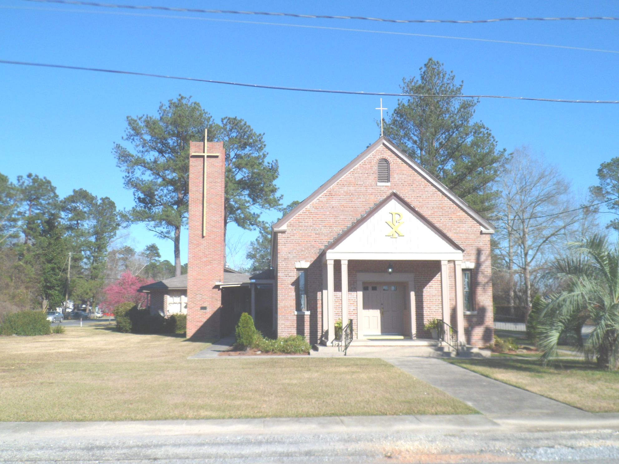
St. Maurice Catholic Church

202 East Jackson St. / P.O. Box 206
Brewton, AL 36427-0206
Rectory: 251-867-5189
Pastor: Rev. Patrick J. Madden
Fr. Pat’s cell # 251-769-3324
pshamrock72011@gmail.com
Deacon Stephen Tidwell- 251-369-3157

Sacrament of Reconciliation: Sat. 5-5:30 PM and anytime by appointment.
BAPTISM: Please contact pastor when you anticipate a baptism in the near future.
WEDDINGS: Please contact pastor/ or deacon at least 6 months prior to the
anticipated date and meet with him for preparation.
ILLNESS: Please contact the Rectory & leave a message, or call Fr. Pat’s cell
number, when a parishioner is ill or in the hospital.

PARISH COUNCIL MEMBERS Finance Committee
- Kelly Davis – Communications 251-363-9362 Ann Peach - 251-363-3313
- Allison Nalty – Social 251-363-3036 Johnny Allan - 251-538-1126
- Deacon Steve Tidwell 251-369-3157 Synod Committee
- Wiley Downing – Finance 251-362-0166 David & Mayra Seitz
- Trish Noble – Youth 251-564-4404 251-538-0238

DAILY MASS – Monday, Tuesday, Wednesday & Friday 7:30 am Religious Education- Not active; Confirmation class begins Jan. 2023

WEEKEND MASS: Saturday, 6:00 PM; Sunday, 8:30 AM
Hispanic Mass – Second and Last Sunday of the Month

(Regular Weekend Mass schedule of Saturday Vigil Masses remains in effect)

December 18 8:30am Mass Fourth Sunday of Advent
December 24 5pm and 9pm Christmas Eve
December 25 8:30 am Mass Christmas Day
January 1 8:30am Communion Service- Deacon Tidwell

Fourth Sunday of Advent

December 18 ,2022

Collection RESULTS: Weekend December 11 –
$6,800.00 Debt reduction-$210.00, Flowers $20

Our parish website is http://saintmauricebrewton.org/
Log on and see what’s next.

Christmas Eve Masses – 5pm and 9pm
Christmas Day Mass – 8:30am

Come join us Sunday Mass 8:30am December 18, followed by a Christmas Breakfast, let us become signs of the Eucharist as we become the Body of Christ to one another.

The First Letter of John reminds us that “In this is love, not that we loved God but that he loved us and sent his Son”. This is the mystery that is at the heart of our Advent prayer and the celebrations of Christmas- preparing to welcome God’s love embodied in the Child Jesus. In these final Advent days, pray that you will discover anew the gift of God’s love in the sights, sounds, and celebrations of this season.

