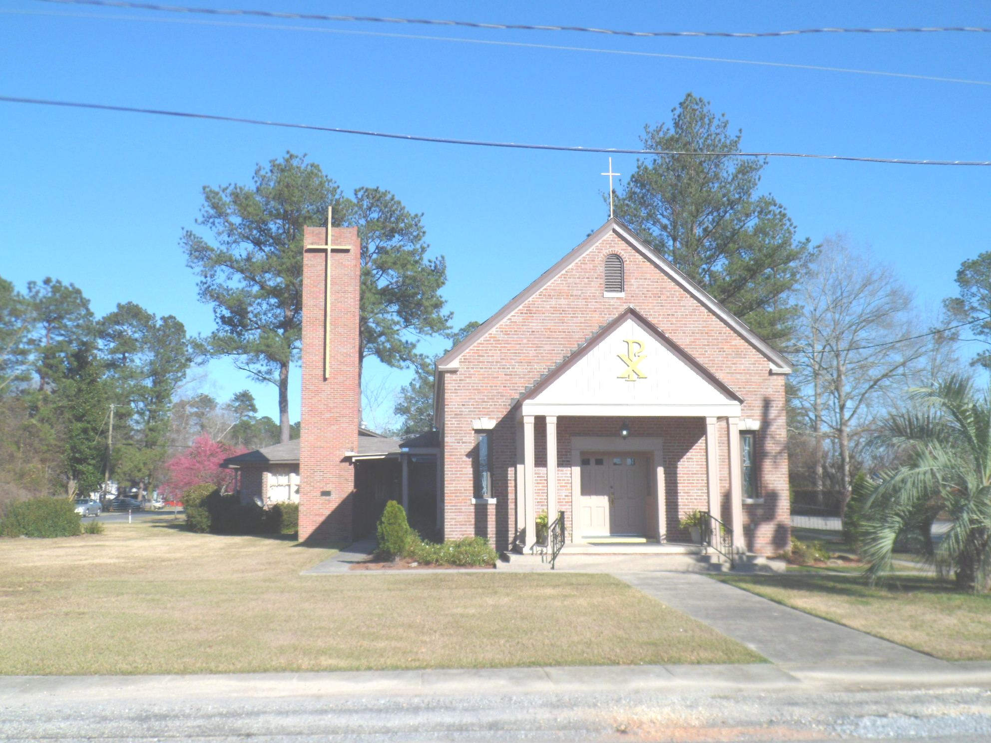
St. Maurice Catholic Church

202 East Jackson St. / P.O. Box 206
Brewton, AL 36427-0206
Rectory: 251-867-5189
Pastor: Rev. Patrick J. Madden
Fr. Pat’s cell # 251-769-3324
pshamrock72011@gmail.com
Deacon Stephen Tidwell- 251-369-3157

Sacrament of Reconciliation: Sat. 5-5:30 PM and anytime by appointment.
BAPTISM: Please contact pastor when you anticipate a baptism in the near future.
WEDDINGS: Please contact pastor/ or deacon at least 6 months prior to the
anticipated date and meet with him for preparation.
ILLNESS: Please contact the Rectory & leave a message, or call Fr. Pat’s cell
number, when a parishioner is ill or in the hospital.

PARISH COUNCIL MEMBERS Finance Committee
- Kelly Davis – Communications 251-363-9362 Ann Peach - 251-363-3313
- Allison Nalty – Social 251-363-3036 Johnny Allan - 251-538-1126
- Deacon Steve Tidwell 251-369-3157 Synod Committee
- Wiley Downing – Finance 251-362-0166 David & Mayra Seitz
- Trish Noble – Youth 251-564-4404 251-538-0238

DAILY MASS – Monday, Tuesday, Wednesday & Friday 7:30 am Religious Education- Not active; Confirmation class begins Jan. 2023

WEEKEND MASS: Saturday, 6:00 PM; Sunday, 8:30 AM
Hispanic Mass – Second and Last Sunday of the Month

(Regular Weekend Mass schedule of Saturday Vigil Masses remains in effect)

January 1 8:30am Communion Service- Deacon Tidwell
January 8 8:30 am The Epiphany of the Lord- Fr. Jose Mesa
January 15 8:30 am Second Sunday in Ordinary Time

The Nativity of the Lord

(Christmas)

December 25 ,2022

Collection RESULTS: Weekend December 18 –
$6,542.33

Our parish website is http://saintmauricebrewton.org/
Log on and see what’s next.

Fr. Madden has a wedding out of town December
31st. Fr. Steve Helman, from Monroeville will celebrate the Saturday Vigil Mass December 31st at 6pm. Deacon Steve Tidwell will hold a Communion Service on Sunday January 1 both the Mass Saturday and Communion service Sunday fulfills the Holy Day obligation for the Solemnity of Mary, Mother of God.

May Each of you have a Blessed and Merry Christmas. Many thanks to all who decorated the Church, and help with each Mass.

