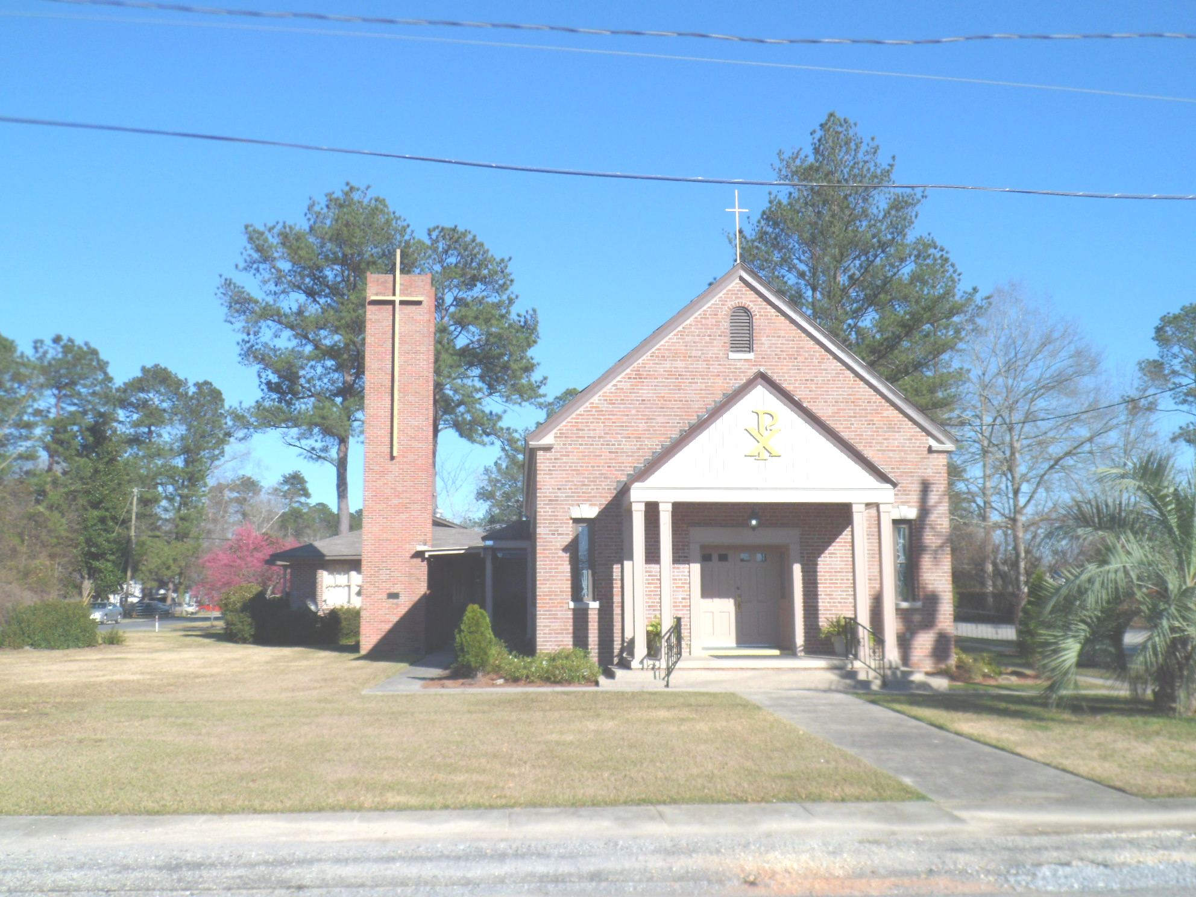
St. Maurice Catholic Church

202 East Jackson St. / P.O. Box 206
Brewton, AL 36427-0206
Rectory: 251-867-5189
Pastor: Rev. Patrick J. Madden
Fr. Pat’s cell # 251-769-3324
pshamrock72011@gmail.com
Deacon Stephen Tidwell- 251-369-3157

Sacrament of Reconciliation: Sat. 5-5:30 PM and anytime by appointment.
BAPTISM: Please contact pastor when you anticipate a baptism in the near future.
WEDDINGS: Please contact pastor/ or deacon at least 6 months prior to the
anticipated date and meet with him for preparation.
ILLNESS: Please contact the Rectory & leave a message, or call Fr. Pat’s cell
number, when a parishioner is ill or in the hospital.

PARISH COUNCIL MEMBERS Finance Committee
- Kelly Davis – Communications 251-363-9362 Ann Peach - 251-363-3313
- Allison Nalty – Social 251-363-3036 Johnny Allan - 251-538-1126
- Deacon Steve Tidwell 251-369-3157 Synod Committee
- Wiley Downing – Finance 251-362-0166 David & Mayra Seitz
- Trish Noble – Youth 251-564-4404 251-538-0238

DAILY MASS – Monday, Tuesday, Wednesday & Friday 7:30 am Religious Education- Not active; Confirmation class begins Jan. 2023

WEEKEND MASS: Saturday, 6:00 PM; Sunday, 8:30 AM
Hispanic Mass – Second and Last Sunday of the Month

(Regular Weekend Mass schedule of Saturday Vigil Masses remains in effect)

January 22 8:30am Mass- CCA Speaker Mrs. Knizley
January 29 8:30am Mass- Catholic Charities Appeal Sunday
11:00am Mass- Spanish
February 5 8:30am Mass

Third Sunday of Ordinary Time

January 22, 2023

Collection RESULTS: Weekend January 15- $3,364.00
Debt reduction- $100.00

Our parish website is http://saintmauricebrewton.org/
Log on and see what’s next.

Catholic Charities Appeal Sunday this year is January 28 & 29, 2023. Mrs. Michelle Knizley, from the Office of Development and Stewardship for the Archdiocese will be our Appeal speaker on the Weekend of January 21-22. This year’s theme is in all things Charity “Blessed are the merciful, for they will be shown mercy.”-Matthew 5:7
May the work of our Catholic Charities Appeal bring your love to all of those in our community. We ask this through your Son, Jesus Christ the Lord.

Our Parish Confirmation class schedule begins January 22 after the 8:30am Mass.

Soul Sister’s next meeting is February 8, 2023

Daily Mass resumes this week, Monday, Tuesday, Wednesday and Friday- 7:30am

