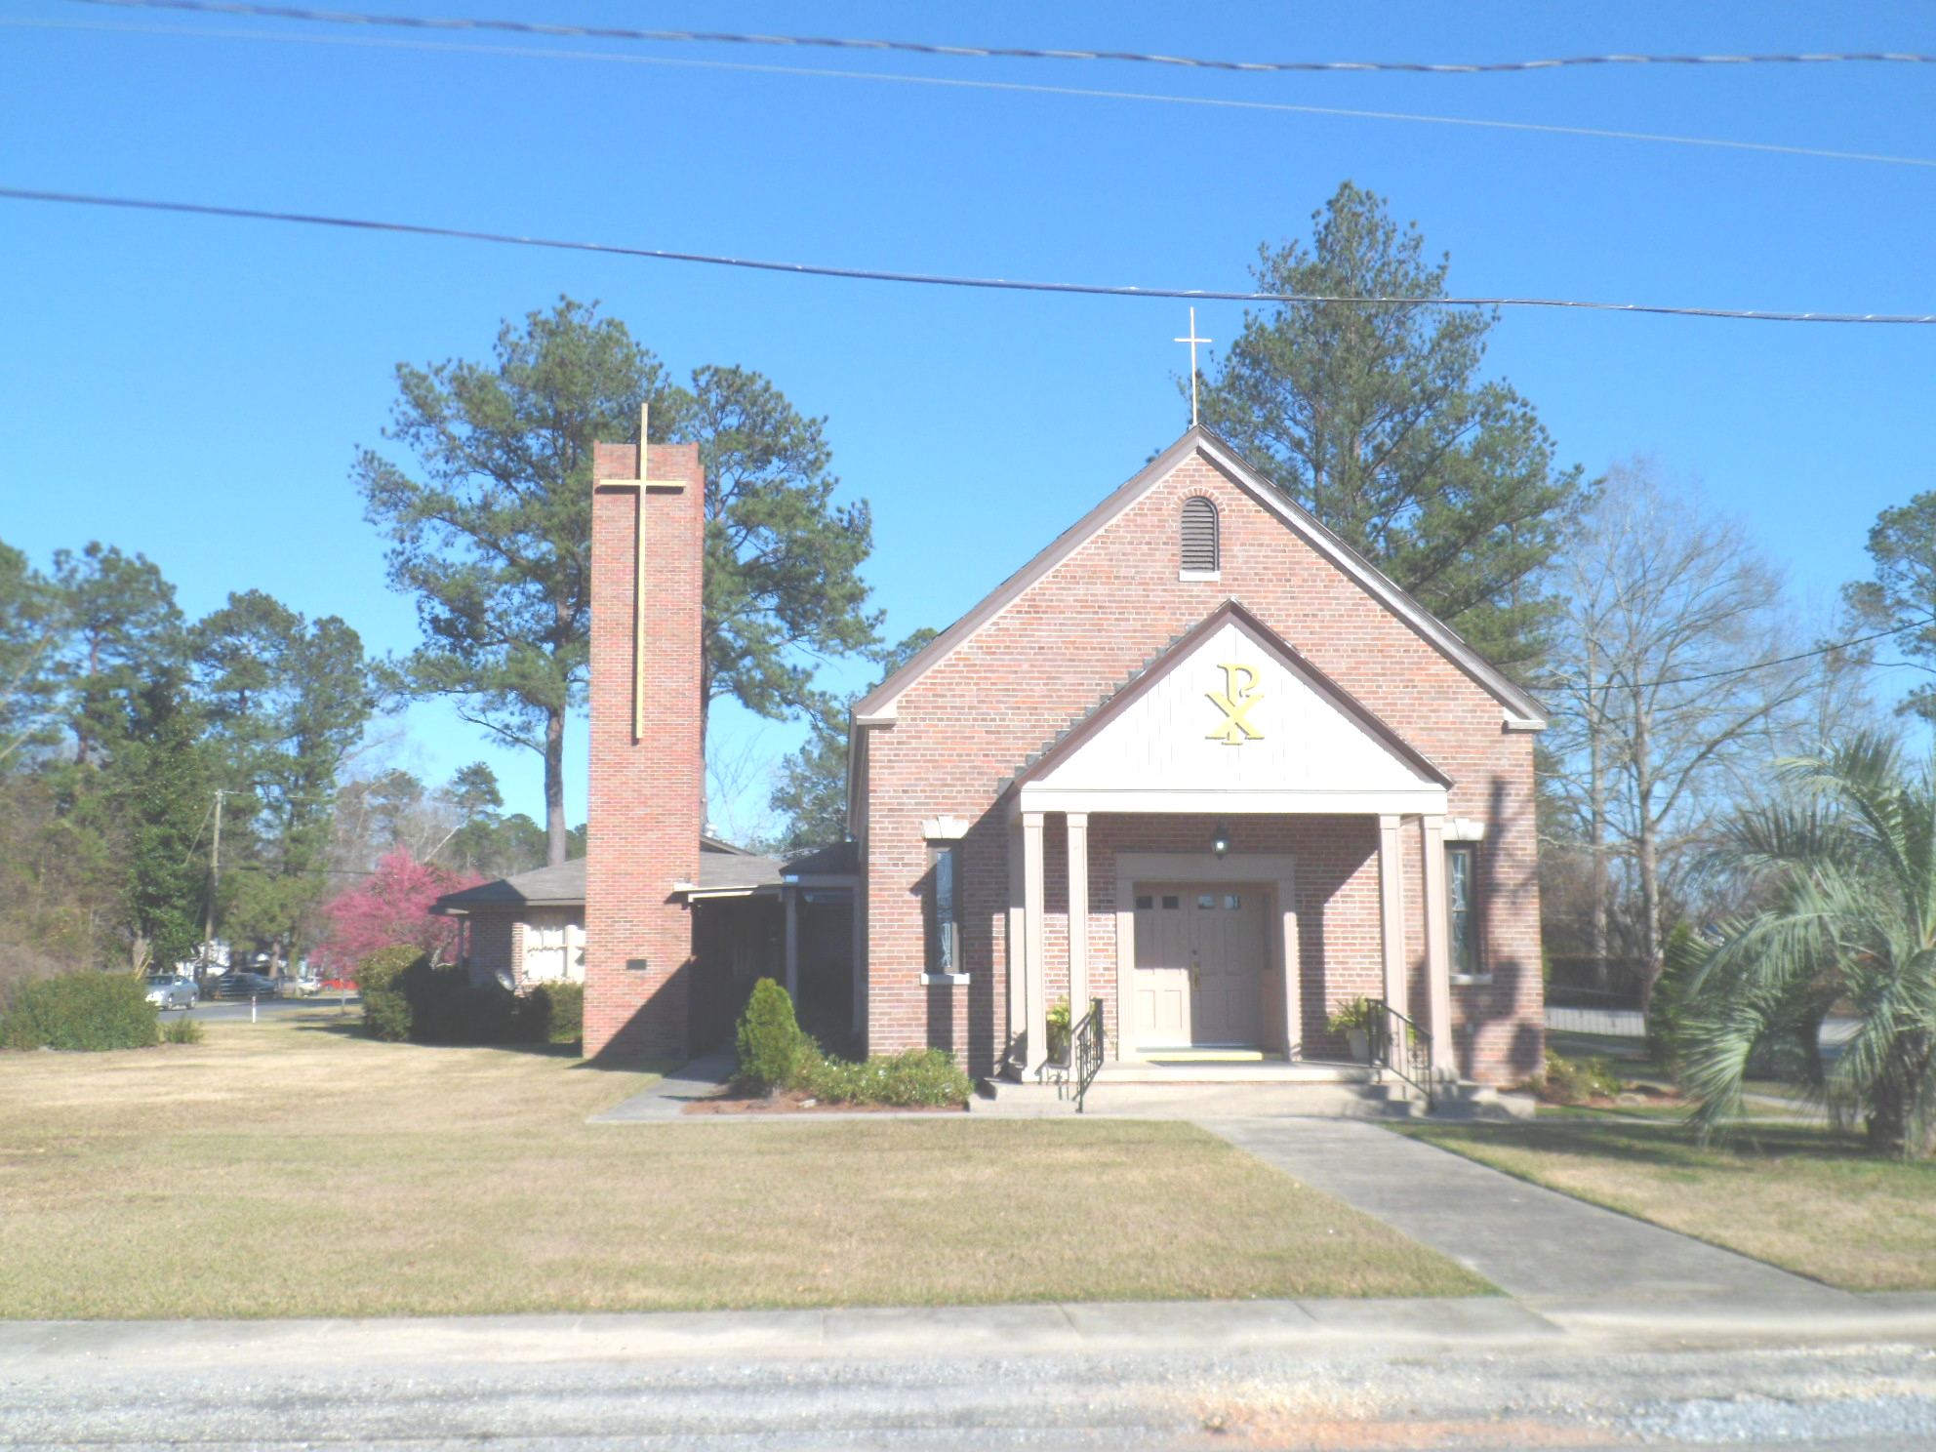
St. Maurice Catholic Church

202 East Jackson St. / P.O. Box 206
Brewton, AL 36427-0206
Rectory: 251-867-5189
Pastor: Rev. Patrick J. Madden
Fr. Pat’s cell # 251-769-3324
pshamrock72011@gmail.com
Deacon Stephen Tidwell- 251-369-3157

Sacrament of Reconciliation: Sat. 5-5:30 PM and anytime by appointment.
BAPTISM: Please contact pastor when you anticipate a baptism in the near future.
WEDDINGS: Please contact pastor/ or deacon at least 6 months prior to the
anticipated date and meet with him for preparation.
ILLNESS: Please contact the Rectory & leave a message, or call Fr. Pat’s cell
number, when a parishioner is ill or in the hospital.

PARISH COUNCIL MEMBERS Finance Committee
- Kelly Davis – Communications 251-363-9362 Ann Peach - 251-363-3313
- Allison Nalty – Social 251-363-3036 Johnny Allan - 251-538-1126
- Deacon Steve Tidwell 251-369-3157 Synod Committee
- Wiley Downing – Finance 251-362-0166 David & Mayra Seitz
- Trish Noble – Youth 251-564-4404 251-538-0238

DAILY MASS – Monday, Tuesday, Wednesday & Friday 7:30 am Religious Education- Not active; Confirmation class begins Jan. 2023

WEEKEND MASS: Saturday, 6:00 PM; Sunday, 8:30 AM
Hispanic Mass – Second and Last Sunday of the Month

(Regular Weekend Mass schedule of Saturday Vigil Masses remains in effect)

February 19 8:30am Mass
February 26 8:30 am Mass – 11am Spanish Mass- 1st Sunday of Lent
March 5 8:30 am Mass

Seventh Sunday of Ordinary Time

February 19, 2023

Collection RESULTS: Weekend February 12- $1,567.00
Catholic Charities Appeal- total $9,693.00
Debt reduction- $10.00

Our parish website is http://saintmauricebrewton.org/
Log on and see what’s next.

Catholic Charities Appeal - Please put your pledge cards in the collection basket or mail them to the Church, P.O. Box 206

Mark the Date: Ash Wednesday Mass February 22^{nd.}
8am. and 6pm.

Kairos Prison Ministry- needs prayers for the men going on a” Cursillo” Retreat March 16-19, 2023, in the prison.
Sign up on the list on the bulletin board at the back of Church.

The next One Faith- One Family Conference Saturday March 18, 2023. Mobile Convention Center

Daily mass update: No Mass on Monday and Tuesday (2/20-21) due to Fr. Madden’s eye surgery.

